Enhancing Gemstone Classification Accuracy: A Deep Learning Approach Using CNN, VGG-19, and Xception

1st Mani Salya Kumar Nadimpalli
School of Computing
VFSTR Deemed to be University
Guntur, India
n.manisalya@gmail.com
4th Tej Tarun Tummalapenta
School of Computing
VFSTR Deemed to be University
Guntur, India
tejtarun683@gmail.com
2nd Karthik Madhu Kiran
School of Computing
VFSTR Deemed to be University
Guntur, India
karthikmadhu7002@gmail.com
5th Sujatha Kamepalli
School of Computing
VFSTR Deemed to be University
Guntur, India
sujatha_kamepalli@yahoo.com
3rd Yasaswi Durga Vundavalli
School of Computing
VFSTR Deemed to be University
Guntur, India
yashuvundavalli@gmail.com

Abstract— Gemstones demand has been steadily on the rise in recent years, driven by various factors. Notably, the soaring popularity of colored gemstones in jewelry designs and the pervasive influence of social media platforms significantly contribute to this trend. A key development in the gemstone market is the growing consumer preference for ethically sourced stones. As consumers become more socially aware, they actively seek out gemstones that are mined and processed with a strong commitment to environmental sustainability and ethical practices. Some gemstones may look alike but their properties, price, rarity may vary, so wrong certification or recognition of the gemstone can be a problem for both dealers and customers. To avoid this there are pre built models like CNN to classify images automatically. In this paper traditional CNN, VGG-19, Xception models are implemented and trained on a large gemstone dataset containing 87 classes. The main aim is to increase the accuracy of the models which can become potential source to classify a gemstone in real time. Finally, it was proved that Xception network is best suited for this task with an accuracy about 92%. This marks the rise of deep learning models in the gemstones field.
Keywords—Gemstones, CNN, VGG-19, Xception, Image Augmentation, Deep Learning Models.

Introduction
Gemstones have always been a symbol of luxury and beauty, prized for their rarity and unique characteristics. In recent years, the demand for these precious stones has been on the rise, driven by their increasing popularity in jewelry designs and the influence of social media [1]. As consumers become more aware of the importance of environmental sustainability and ethical practices, they are seeking out gemstones that are mined and processed with a strong commitment to these values [2]. This shift in consumer behavior has led to a growing demand for gemstones that not only sparkle with beauty but also align with their values. However, the complexity of gemstone identification poses a significant challenge to both dealers and customers. With many gemstones looking alike, wrong certification or recognition can be a major problem [3]. The consequences of misidentification can be severe, leading to financial losses, damage to reputation, and even legal disputes. Moreover, the lack of transparency in the gemstone supply chain makes it difficult to track the origin and authenticity of gemstones. To address this issue, deep learning models have emerged as a potential solution, offering a way to classify images automatically and accurately. By leveraging the power of machine learning, it is possible to develop a reliable and efficient system for gemstone identification.
In this paper, we explore the use of traditional CNN, VGG-19 [4], and Xception models to classify gemstones in real-time. Our goal is to increase the accuracy of these models, which can become a reliable source for gemstone identification [5]. By training these models on a large dataset of 87 classes, we aim to prove that deep learning can revolutionize the gemstone industry. With the ability to accurately identify gemstones, dealers and customers can make informed decisions, and the industry can move towards greater transparency and accountability [6] [7]. The potential impact of this technology is significant, and we believe that it can play a critical role in shaping the future of the gemstone industry. The dataset used in this study, available on Kaggle under the name "Gemstone images," includes over 3,200 images categorized into 87 classes, pre-divided into training and testing sets. This comprehensive dataset allows for robust training and validation of the models, ensuring they can handle the diverse and intricate nature of gemstone images, ultimately leading to more reliable and precise gemstone classification.

Structure of the paper
The introduction tells about the issues faced in identifying a gemstone and the deep learning models that were used to address this issue. In the methodology section the details of the implementation of the deep learning models along with flow of work is present. In the results section the entire analysis is provided and discussion section provides the findings of this work.

Objectives
- To examine the deep learning models used for detecting Gemstones.
- To create deep learning models capable identifying gemstones with high accuracy.
- Examine the efficiency of various image pre-processing approaches.
- To identify a particular gemstone.
- To assess the Deep learning models overall accuracy.

RELATED WORK
The demand for gemstones continues to increase due to their popularity in the jewellery industry and the influence of social media, as well as the growing consumer preference for ethically sourced stones [1]. The complexity of gemstone identification, where many gemstones look similar, poses a challenge for dealers and customers, leading to potential financial and reputational risks due to misidentification. To address this issue, deep learning models have emerged as a viable solution. This paper explores the use of traditional CNN models, VGG-19 [4] and Xception [8], trained on a large dataset of 87 classes to improve gemstone classification accuracy. Previous research has shown that image preprocessing techniques, such as resizing and noise reduction, are critical to improving model performance. While traditional CNNs work well, advanced architectures such as VGG-19 and Xception offer improved accuracy. The use of VGG-19’s small convolutional filters and Xception’s depth-separable convolutional filters are said to be particularly effective, with the Xception model achieving 86% accuracy in gemstone classification [9] [10]. This advance highlights the potential of deep learning to revolutionize the gemstone industry, providing reliable, real-time identification tools that promote transparency and ethical practices. Future research could further improve these models and their accuracy and explore their application in other areas of the gemstone supply chain, contributing to greater accountability and sustainability in the industry.

METHODOLOGY
The dataset, available on Kaggle under the name "Gemstone images," contains over 3,200 images of various gemstones. These images are categorized into 87 classes and are pre-divided into training and testing sets. All images are in .jpeg format and vary in size. The dataset is organized into two main folders: the train folder, approximately 56 MB in size, includes 87 subfolders with around 2,800 images in total, each subfolder representing different gemstones. The test folder, approximately 8 MB, also contains 87 subfolders but with around 400 images in total, similarly representing different gemstones.
Initially once the data set was loaded into the colab environment, the first major problem identified was the size issue. All the images were of different sizes. This could really cause a problem while working with Image classification algorithms since the architectures accept inputs of the same size. So a good amount of time was spent on resizing the entire dataset of 3200 images into 256*256.
The next step is to ensure that each class in an image dataset has at least 100 images by first counting the number of images in each class folder. If a class has fewer than 100 images, ImageDataGenerator` to augment the existing images by applying random transformations like rotation, zoom, and flips, generating new images until the target of 100 images per class is reached. This process is done to balance the dataset, which is beneficial for training machine learning models.
In each model considered the parameters like number of epochs, batch size is randomly changed and executed in order to optimize the model to get high accuracy. The aim is to get the highest possible accuracy by reducing the time factor.
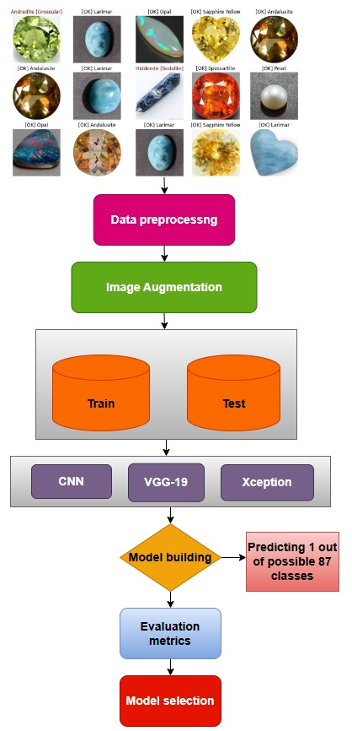

Fig. 1. Flow of the work

Convolution Neural Network
Various deep learning models have been applied to the following dataset to pick out the maximum accuracy model among CNN, Xception, and VGG19 [11]. The highest accuracy has been obtained by the Xception model. This architecture has the initial convolution layer(conv2d) employing 15 filters succeeded by a subsequent layer featuring 64 filters The in- depth explanation of the model is implied in TABLE II. Along with the conv2d, Max-pooling also serves as the down sample of feature maps. Next, we have additional two convolution layers with the subsequent layer featuring 64 filters. followed by an additional max-pooling layer. Again there will be two convolution layers with 128 filters each, followed by a max- pooling layer The architectural configuration is completed with three fully connected dense layers, featuring 512, 256, and 16 units, respectively, ultimately culminating in an output layer incorporating sigmoid activation.
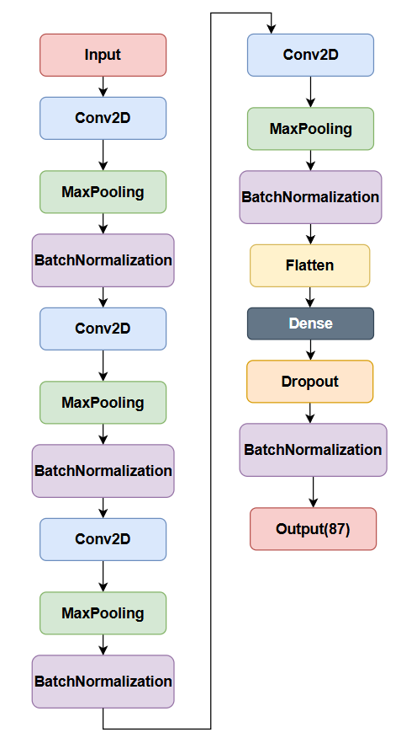
Fig. 2. CNN model

VGG 19
VGG-19 is a deep neural network architecture introduced by the Visual Geometry Group at Oxford in 2014 [12]. It comprises 19 layers, including 16 convolutional layers and 3 fully connected layers, and is designed with a simple and uniform structure. The model processes input images, typically 224x224 pixels with 3 colour channels, through a sequence of convolutional operations. Each convolutional layer employs 3x3 filters, with the number of filters doubling as the network deepens,
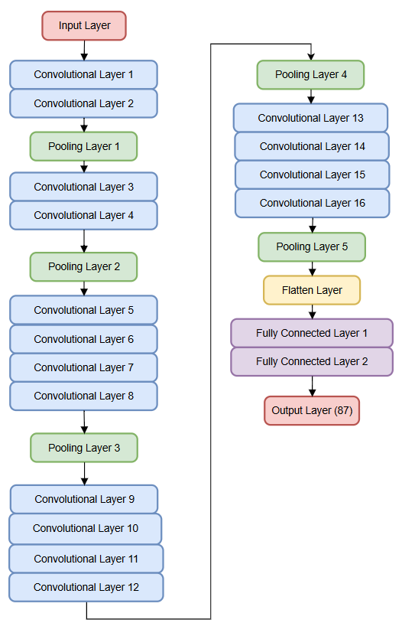
Fig. 3. VGG 19 Architecture
starting with 64 filters in the initial layers and increasing to 512 filters in the later layers. These layers are organized into five stages, each followed by a 2x2 max-pooling operation to reduce the spatial dimensions of the feature maps. After the convolutional stages, the feature maps are flattened into a single vector and passed through two fully connected layers, each with 4096 units, followed by a final fully connected layer with 1000 units for classification tasks, such as those in the ImageNet dataset. The output layer uses a softmax activation function to produce a probability distribution over the 1000 classes. VGG-19 is known for its depth and consistent use of 3x3 convolutional filters, which contribute to its effectiveness in image classification. Despite being an old model, VGG-19 continues to be widely used, particularly in transfer learning and some other specialized tasks [9].

Xception
Xception is a deep neural network architecture introduced by Francois Chollet in 2017, designed as an extension of the Inception model.
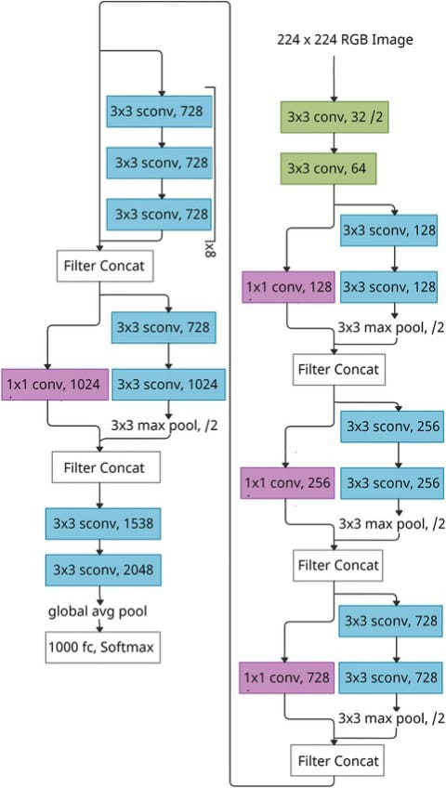
Fig. 4. Xception mode

It replaces traditional convolutions with depthwise separable convolutions to improve efficiency and reduce the number of parameters while maintaining high accuracy. The architecture is divided into three main parts: Entry Flow, Middle Flow, and Exit Flow [13] [14]. In the Entry Flow, the model processes the input through initial convolutional layers and then through blocks of depthwise separable convolutions with increasing filter sizes, followed by max-pooling layers. The Middle Flow consists of eight identical blocks, each with three depthwise separable convolutional layers. In the Exit Flow, the model further refines features through additional convolutional layers before applying global average pooling, followed by a dense layer and a softmax output for classification [8].

RESULTS AND INTERPRETATION
Several models were used to determine different types of gemstones and many deep learning models are put into practice once the data has been preprocessed. CNN, VGG-19 and Xception are among them.

Dataset Description
The dataset consists of two folders test and train, in each of these folder there are 87 folders which represent the type of gemstones. From table 2 we will know the number of original images and augmented images.
- THE DATASET CONTAINS TYPES OF SAMPLES
Dataset details | Total Count
Original Images | 3200
Augmented Images | 5500
Total | 8700

The following shows the visualization of the class wise data samples considered for experimentation.
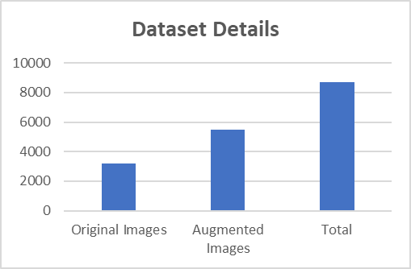
Fig. 5. The dataset contains class-wise samples
Before augmentation of the images initially there were only around 3200 images but there are 87 classes. So the accuracy was too low than the current obtained results. After augmentation and resizing the accuracy increased for all the 3 models selected.
From the below table III, we can know the count of the train set and test set. Here splitting percentage is 80% for training and 20% for testing. 80-20 split was preferred over 70-30 split in order to allocate more data to the training since there are 87 different classes.

- TRAIN AND TEST SPLIT
Type of Image | Training | Testing | Total
Original | 2560 | 640 | 3200
Augmented | 4400 | 1100 | 5500
Total | 6960 | 1740 | 8700

The following image shows some random images from the train folder , since there are 87 classes the image will contain images of some random gemstone classes.

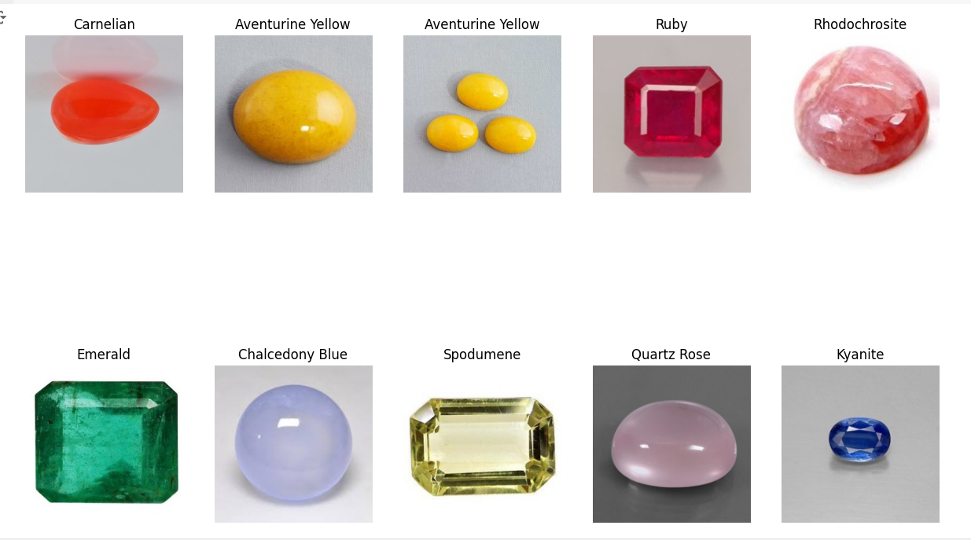
Fig. 6. Random images of different Gemstones present in the Dataset

The following represents the training and test set samples count in the experimentation.
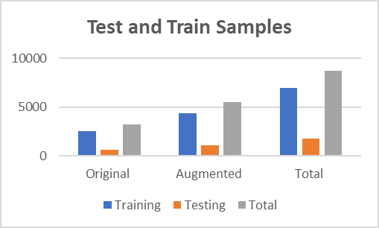
Fig. 6. Train and Test Split

Model Performance
The following images shows the training and validation loss, accuracy over Epochs for the VGG-19 model.

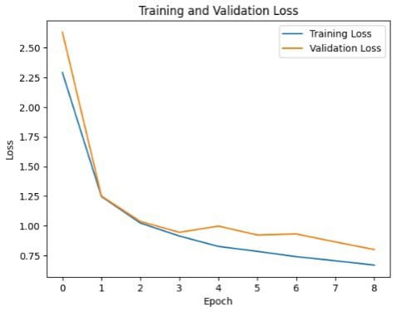
Fig.7.Training, validation loss over Epochs(VGG-19)
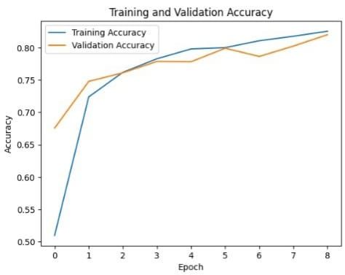 Fig. 8. Training, validation accuracy over Epochs(VGG-19)

The following images shows the training and validation loss, accuracy over Epochs for the Xception model.

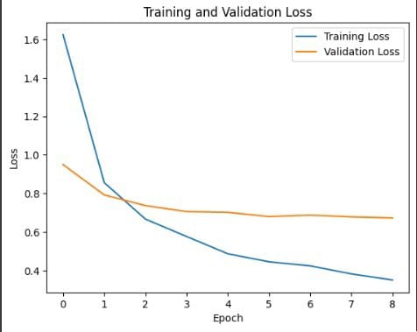

Fig. 9. Training, validation loss over Epochs(Xception)

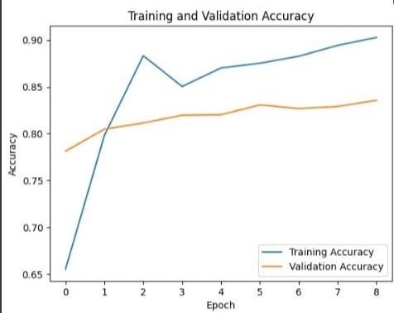
Fig. 10. Training, validation accuracy over Epochs(Xception)
The following table displays the total accuracy of the models. The values were obtained by deploying various deep-learning models on the dataset.
- ACCURACY OF THE VARIOUS MODELS
Model | Accuracy
CNN | 75.12
VGG-19 | 79.59
Xception | 85.21

The following chart shows information about the overall performance of the different deep-learning models on image classification.
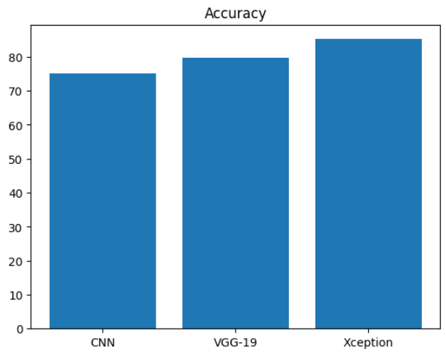
Fig. 11. Overall performance of models
The following images shows the prediction of Xception model on some Gemstones Chosen randomly from the dataset.
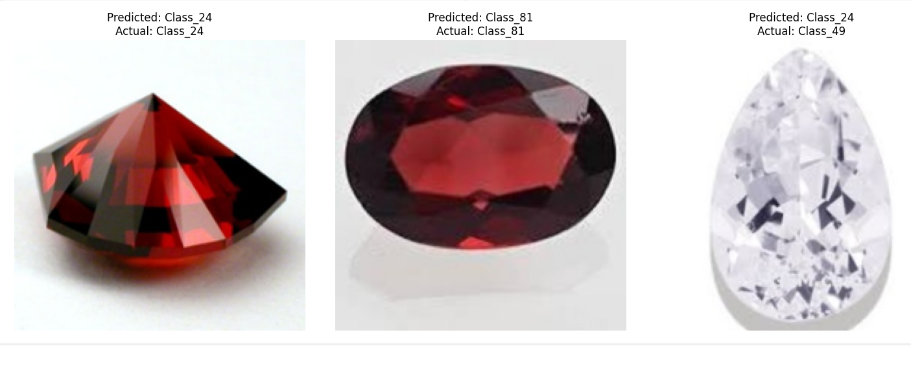
Fig. 12.Prediction on random images using Xception model.
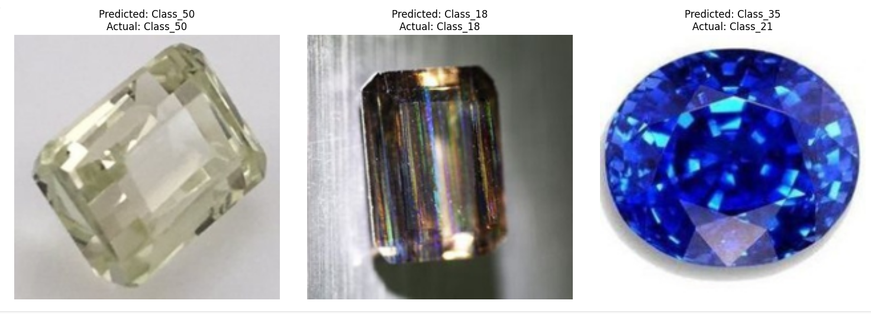
Fig. 13..Prediction on random images using Xception model.

Out of the three models which were implemented , Convolutional Neural Network (CNNN) achieves an accuracy of 75.12% , VGG-19 achieves an accuracy of 79.59% and Xception achieves 85.21% . It is very clear that Xception achieved the maximum accuracy on this dataset with an impressive accuracy of 85.21% , making it a best option when compared to the other models.

CONCLUSION
The increasing demand for gemstones, coupled with the need for ethical sourcing, highlights the importance of accurate and reliable gemstone classification. In this paper, we explored the effectiveness of deep learning models, specifically CNN, VGG-19, and Xception, in classifying a diverse set of gemstones. Our experiments demonstrated that the Xception model outperforms the others, achieving an accuracy of approximately 85%. This high level of accuracy suggests that deep learning models, particularly Xception, hold significant promise for real-time gemstone classification. These findings pave the way for the development of automated, reliable tools that can assist both dealers and consumers in making informed decisions, thereby promoting transparency and trust in the gemstone market. The success of the Xception network marks a notable advancement in the application of deep learning to the gemstone industry, setting a new standard for future research and practical implementations.

References

[1] P. Hurtik, M. Vajgl, and M. Burda, “Jewelry stones classification: Case study,” in 7th International Conference of Soft Computing and Pattern Recognition, SoCPaR 2015, 2016, pp. 205–210. doi: 10.1109/SOCPAR.2015.7492808.
[2] S. Sharma and K. Guleria, “Deep Learning Models for Image Classification: Comparison and Applications,” in 2nd International Conference on Advance Computing and Innovative Technologies in Engineering, ICACITE 2022, 2022, pp. 1733–1738. doi: 10.1109/ICACITE53722.2022.9823516.
[3] V. Tiwari, C. Pandey, A. Dwivedi, and V. Yadav, “Image Classification Using Deep Neural Network,” in 2nd International Conference on Advances in Computing, Communication Control and Networking, ICACCCN 2020, 2020, pp. 730–733. doi: 10.1109/ICACCCN51052.2020.9362804.
[4] M. T. Chowdhury, H. Rahman, M. I. Sumon, and A. Talha, “Classification of satellite images with VGG19 and Convolutional Neural Network (CNN),” in 2nd International Conference on Advancement in Computation and Computer Technologies, InCACCT 2024, 2024, pp. 397–402. doi: 10.1109/InCACCT61598.2024.10551185.
[5] H. Tang, “Image Classification based on CNN: Models and Modules,” in International Conference on Big Data, Information and Computer Network, BDICN 2022, 2022, pp. 693–696. doi: 10.1109/BDICN55575.2022.00134.
[6] K. Sujatha and B. Srinivasa Rao, “Recent Applications of Machine Learning : A Survey,” Int. J. Innov. Technol. Explor. Eng., vol. 8, no. 6, pp. 263–267, 2019, doi: Retrieval Number: F10510486C219 /19©BEIESP.
[7] K. Sujatha and P. Mounika, “Evaluation of ML Models for Detection and Prediction of Fish Diseases : A Case Study on Epizootic Ulcerative Syndrome,” econd Int. Conf. Electr. Electron. Inf. Commun. Technol., pp. 1–7, 2023, doi: 10.1109/ICEEICT56924.2023.10156914.
[8] X. Wu, R. Liu, H. Yang, and Z. Chen, “An Xception Based Convolutional Neural Network for Scene Image Classification with Transfer Learning,” in 2nd International Conference on Information Technology and Computer Application, ITCA 2020, 2020, pp. 262–267. doi: 10.1109/ITCA52113.2020.00063.
[9] L. Wen, X. Li, X. Li, and L. Gao, “A new transfer learning based on VGG-19 network for fault diagnosis,” in IEEE 23rd International Conference on Computer Supported Cooperative Work in Design, CSCWD 2019, 2019, pp. 205–209. doi: 10.1109/CSCWD.2019.8791884.
[10] R. Chauhan, K. K. Ghanshala, and R. C. Joshi, “Convolutional Neural Network (CNN) for Image Detection and Recognition,” in 1st International Conference on Secure Cyber Computing and Communications, 2018, pp. 278–282. doi: 10.1109/ICSCCC.2018.8703316.
[11] J. Zhai, L. Zang, and S. Zhang, “SOME INSIGHTS INTO CONVOLUTIONAL NEURAL NETWORKS,” in International Conference on Machine Learning and Cybernetics, 2017, pp. 123–129.
[12] A. Mikołajczyk and M. Grochowski, “Data augmentation for improving deep learning in image classification problem,” in International Interdisciplinary PhD Workshop, IIPhDW 2018, 2018, pp. 117–122. doi: 10.1109/IIPHDW.2018.8388338.
[13] S. Kamepalli, S. R. Bandaru, and C. S. R. Nannapaneni, “Custom-Built Deep Convolutional Neural Network for Breathing Sound Classification to Detect Respiratory Diseases,” in Proceedings of International Conference on Computational Intelligence and Data Engineering, 2023, no. August, pp. 1–8.
[14] N. Abhinav and K. Sujatha, “Content-Based Movie Recommendation System Using cosine similarity measure,” in AIP Conf. Proc. 2901, 060035 (2023), 2023, vol. 2901, pp. 1–10. [Online]. Available: https://doi.org/10.1063/5.0178819

